Instructions for using the "IO_Checkout_Tool"
This tool will generate:
- the CP's input files (*.i) with the IO test blocks for pushing them to the CP using the iccdrvr.tsk.
- the batch file (*.bat) which can be run by double-click it to enable all ChildECB's.
Instructions:
1. Place the whole folder somewhere on the computer (desktop, or C drive, or D drive).
2. Double-click "IO Checkout Tool.zip" folder, then double-click "setup.exe." The "setup.exe" will run inside the zipped folder and install it on the computer.
3. The GUI below will appear.
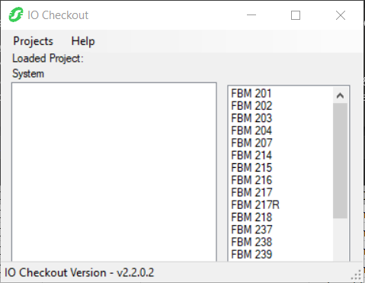
4. Click Projects, select New. New Project window will appear.
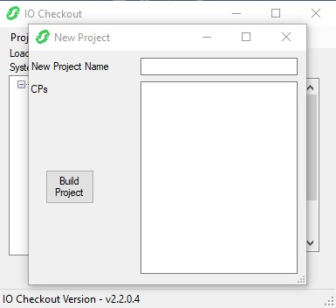
5. Enter new project name. And add all CP’s into of the project here. Then click Build Project.
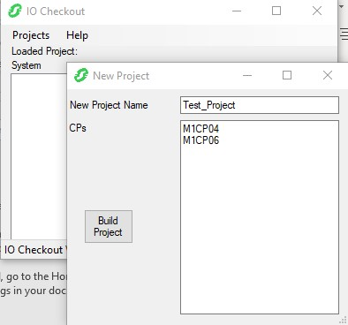
6. The CP’s and ECB compounds are now created.
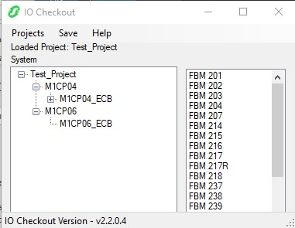
7. Click on the an FBM from the list on the right, drag and drop it to a CP on the left. Right click on that FBM and select Configure.
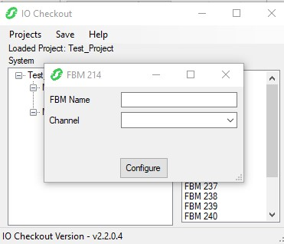
8. Enter FBM letterbug, select Channel 1 if using CP’s other than FCP280. If using FCP280, then select the appropriate Channel the FBM is connected to. If making a mistake with the FBM assignment, then right click on that FBM and select Remove.
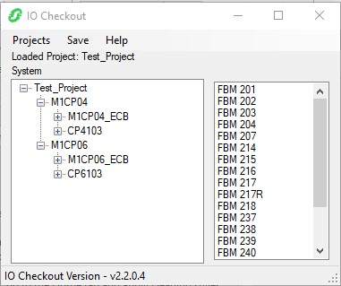
9. After finishing adding all FBM’s to the CP’s, right click on each CP and select Build. Expand the FBM’s will reveal the test blocks created automatically by the tool.
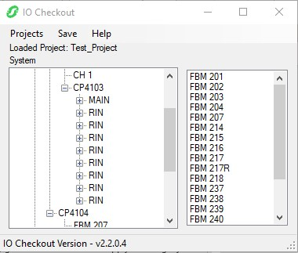
10. After Building from Step 9 above, the CP’s *.i and ChildECBEnable_<CP_Name>.bat will be created in C:\Users\<sesaID>\Documents\IO Checkout Files\Test_Project.
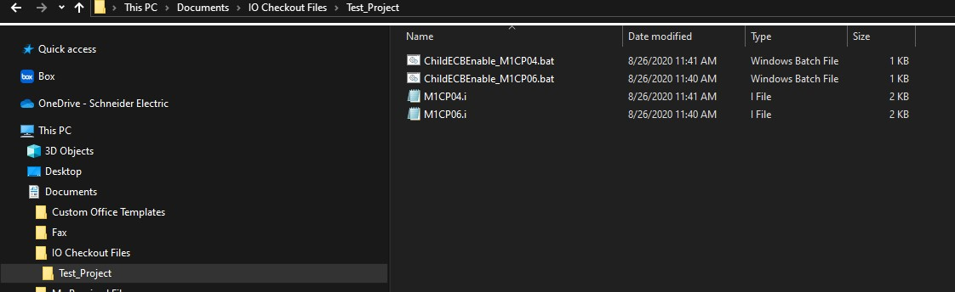
11. Copy all these files to the D drive of the IA station hosting the CP’s. Start a Command Prompt in Admin mode and run iccdrvr.tsk (in /opt/fox/ciocfg/api directory) to add the input files to the CP's.
iccdrvr.tsk -i inputfile.i -o outputfile
Example: iccdrvr.tsk -i M1CP04.i -o cp0101.o
12. From System Management, put the FCM's and parent ECB's on-line. For Windows Station: Files ChildECBEnable_<CP_Name>.bat will be automatically generated. Edit these .bat file (if necessary) for the appropriate CP names, and ECB names. Then run these files (one at a time) by double clicking them to put all child ECB's on-line.

